Shabbos Stories For
Parshas Ki-seitze 5786
Volume 17, Issue 50 9 Elul/August 22, 2026
Printed L’illuy nishmas Nechama bas R’ Noach, a”h

The Partial Donation

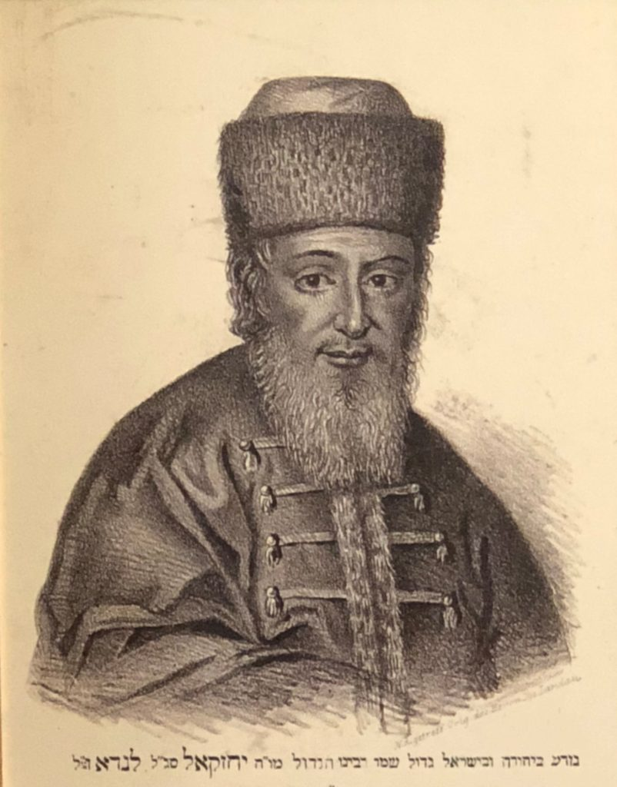

The Noda B’Yehudah, Rav Yechezkel Landau, zt”l, was once approached by two prominent leaders of the generation regarding a matter of redeeming a person who was captured in prison. They told him that in order to liberate the captive they raise a sum of 300 gold coins.
The Noda B’Yehudah immediately went into his room and returned to them with 290 gold coins. He told them, "This is the amount I am giving you. The rest you will collect from others."
The two organizers were extremely happy to receive so much of what they were looking to collect in such a short time and thanked the Noda B’Yehudah for his help. As they were leaving, one of them said that he had a question to ask of the Rav.
"You gave us almost the entire amount that we needed to rescue the one in jail. Why wouldn’t the Rav give us the entire amount, that for the relatively smaller amount of 10 gold coins do we have to go collecting from others?"
The Noda B’Yehudah answered them, "The Mishnah in Avos (5:16) says that if one wishes to give Tzedakah but wants others not to give, then he it is considered as if he is being evil to others. It is for this reason that I specifically would like others to join in and help donate towards this worthy cause!"
(Although the Noda B’Yehudah didn't quote the entire Mishnah, the Mishnah later on says that one who gives Tzedakah and also causes others to give as well is a Chasid— a pious, righteous individual— clearly someone who the Noda B’Yehudah certainly was!)

Reprinted from the Parshas Eikev 5786 email of Rabbi Yehuda Winzelberg’s Torah U’Tefilah
The Grand Prize

By the time Shlomo reached the age of twenty-seven, shidduchim had become his personal Keriat Yam Suf. He did not consider himself particularly picky, yet one suggestion after another led nowhere, while many of his friends were already married with young children.
One evening he traveled to Bnei Brak for the wedding of a younger friend. After the chuppah, a little dancing, and a quick bite to eat, he headed for the bus back to Yerushalayim. On the way, he stopped to chat with an old friend outside a building, when a man came out and urged them to come upstairs to a Sheva Berachot. "We still don't have a minyan," he pleaded.
Shlomo declined, saying he was in a hurry, but the man smiled and said, "Come up—you'll get a prize." Though the promise of a prize meant little to him, the man's warmth convinced him to go. Upstairs, he found a painfully quiet Sheva Berachot with only a handful of relatives sitting awkwardly around the hatan and kallah. Once a minyan was finally assembled, the man asked Shlomo to lead the singing, which quickly lifted the atmosphere.
A few minutes later he made an even stranger request: "Now say a few words." Shlomo protested that he had never even met the hatan, but after being given a few details about him, he rose and delivered a heartfelt speech, praising the hatan's diligence and sterling qualities, concluding with warm wishes for the new couple. The room came alive, and the delighted hatan embraced him.
During dessert, another guest asked Shlomo his name and then surprised him by suggesting his niece as a shidduch. When Shlomo wondered how he could make such a suggestion without knowing him, the man replied, "After hearing you speak and seeing that you came just to help complete a minyan for people you didn't even know, I feel I know enough. Why not try?"
Shlomo gave him his parents' phone number, and that suggestion eventually led to the woman who became his wife. Years later, Shlomo boarded a bus and recognized a familiar face. After a few moments, the man exclaimed, "You're the one who spoke at my brother's Sheva Berachot!" Then he suddenly remembered. "I promised you a prize that night, and I never gave it to you."
Smiling, Shlomo replied, "Don't worry—Hashem fulfilled your promise." He then told him that another guest at that very Sheva Berachot had suggested the shidduch that became his wife. "Your prize turned into my family," he said as the bus reached his stop. "I have to go now—those prizes are waiting for me at home." (Meant To Be)

Reprinted from the Parashat Ekeb 5786 email from Rabbi David Bibi’s Shabbat Shalom from Cyberspace.

Greatness and Humility
By Rabbi Lord Jonathan Sacks, z”l
Former Chief Rabbi of the United Kingdom and the Commonwealth


Rabbi Lord Jonathan Sacks, z”l

One of the more unusual aspects of being a Chief Rabbi is that one comes to know people one otherwise might not. These were three moments that made a deep impression on me.
From time to time, Elaine and I give dinner parties for people within, and also outside, the Jewish community. Usually, at the end, the guests thank the hosts. Only once, though, did a guest not only thank us but also ask to be allowed to go into the kitchen to thank those who had made and served the meal. It was a fine act of sensitivity. No less interesting was who it was who did so. It was John Major, a British Prime Minister. Greatness is humility.

Oldest British Synagogue was
Built by Spanish and Portuguese Jews
The oldest synagogue in Britain is Bevis Marks, in the heart of the City of London. Built in 1701, it was the first purpose-built synagogue in London, created by the Spanish and Portuguese Jews who were the first to return to England (or practice their Judaism in public: some had been marranos) after Oliver Cromwell gave permission in 1656 for Jews to return after their expulsion by Edward I in 1290.
Modelled on the Great Synagogue in Amsterdam, it has stayed almost unchanged ever since. Only the addition of electric lights has marked the passing of time – and even so, on special occasions, services are candle-lit as they were in those early days.
For the tercentenary service in 2001, Prince Charles came to the synagogue. There he met members of the community as well as leaders of Anglo-Jewry. What was impressive is that he spent as much time talking to the young men and women who were doing security duty as he did to the great and good of British Jewry. For security reasons, people volunteer to stand guard at communal events – part of the work of one of our finest organisations, the Community Security Trust. Often, people walk past them, hardly noticing their presence. But Prince Charles did notice them, and he made them feel as important as anyone else on that glittering occasion. Greatness is humility.

They Gave Tzedakah on a Massive Scale
Sarah Levene (not her real name) died tragically young. She and her husband had been blessed by G-d with great success and they were extremely wealthy; but they did not spend their money on themselves. They gave tzedakah on a massive scale – within and beyond the Jewish community, in Britain, Israel and elsewhere. They were among the greatest philanthropists of our time.
When Sarah died, among those who felt most bereaved were the waiters and waitresses of a well-known hotel in Israel where they often stayed. It transpired that she had come to know all of them – where they came from, what their family situation was, the difficulties they were going through, the problems they faced. She remembered not only their names but also the names of their spouses and children. Whenever any of them needed help, she made sure it came, quietly, unobtrusively. It was a habit she had wherever she went.
After her death I discovered how she and her husband came to be married. He was older than she was, a friend of her parents. She had some weeks free in the summer before the start of the academic year, and Mr. Levene (not his real name) gave her a holiday job. One evening after work they were about to join her parents for a meal.
In the street they passed a beggar. Mr. Levene, punctilious about the mitzvah of tzedakah, reached into his pocket and gave the man a coin. As they were walking on, Sarah asked him to lend her some money – a fairly large sum, which she promised she would repay at the end of the week when he paid her wages.
He did so. She then ran back to the beggar and gave him the money. “Why did you do that?” he asked, “I had already given him some money.” “What you gave him,” she said, “was enough to help him for today but not enough to make a difference to his life.”
At the end of the week, Mr. Levene gave Sarah her wages. She handed him back most of the money, reminding him that she had to repay him for the sum he had lent her. “I will accept the money,” he told her, “Because I do not want to rob you of your mitzvah.” But – as he himself told me after her death, “It was then that I decided to ask her to marry me – because her heart was bigger than mine.”
Throughout their marriage they spent as much time and energy on giving their money to charitable causes as they did on earning it. They were responsible for many of the most outstanding educational, medical, and environmental projects of our time. I have had the privilege of knowing other philanthropists – but none who knew the names of the children of the waiters at the hotel where they stayed; none who cared more for those others hardly noticed or who gave help more quietly, more effectively, more humanly. Greatness is humility.
This idea – counter-intuitive, unexpected, life-changing – is one of the great contributions of the Torah to Western civilisation and it is set out in the words of our sedra, when Moses told the people about the “G-d of gods and L-rd of lords, the great, mighty, and awe-inspiring G-d” whose greatness lay not just in the fact that He was Creator of the universe and shaper of history, but that “He upholds the cause of the orphan and widow, and loves the stranger, giving him food and clothing.” Those who do this are the true men and women of G-d.

Reprinted from the Parashat Ekeb 5786 email of Shabbat Shalom from Cyberspace.



A Delayed Last
Goodbye to Their Rebbe


Rabbi Hillel Eisenberg

Rabbi Hillel Eisenberg shares an astounding story about the tremendous knowledge our religious leaders have. In December, 1988 a group of 33 chassidim traveled from Brooklyn to London for the wedding of their Rebbe’s son. After several days of learning and celebrating with their Rebbe at Stanford Hill they packed their bags to return home to their families and businesses. On the last day, although short on time, the chassidim decided to say one last goodbye to their Rebbe and get berachot before their flight.
They arrived at the Rebbe’s house and asked the secretary if the Rebbe had a minute or two to give them a blessing. The secretary said, “Of course. The Rebbe has nothing scheduled for this morning. Let me tell him you’re here.” The secretary returned a minute later and said, “The Rebbe is free now, but he would like you to wait a few minutes before he sees you.” The chassidim said that that was not an issue and they sat down and waited.
A couple of minutes later they asked the secretary if he could ask the Rebbe again, because they were on they had a flight soon. The secretary returned a minute later and said, “The Rebbe said you should wait a couple of more minutes, and there is no need to worry about missing the plane.”
Ten minutes passed, and the chassidim were getting nervous. Should they leave despite the Rebbe telling them to wait? They had families and jobs to get back to. How could they miss their flight? They decided to listen to the Rebbe, and ten nerve-racking minutes later they were called in.

The Rebbe’s Apology to His Chassidim
The Rebbe apologized for making them wait and assured them it would all work out. He shook their hands and gave them warm berachot. He walked them slowly to their bus. Meanwhile, each chassid wanted to rush on their bus and speed to the airport, but the Rebbe would not allow it. He slowly, almost deliberately, gave each person another lengthy and time-consuming beracha.
When the Rebbe was finally finished, they hopped on the bus and sped to the airport. They dashed through the terminal and at the gate they discovered that the plane had left without them. The men were flustered and aggravated. They sat down in the airport to figure out a plan.
A few minutes later there was a commotion in the airport. Everyone rushed to tiny TV screens that broadcast horrific news. A Pan Am flight from Heathrow Airport had just blown up over Scotland killing all the passengers and crew members on board as well as numerous people in the crash. The chassidim’s hearts stopped beating as they saw the flight number on the screen.

The Exact Flight That They Missed
Flight number 103, the exact flight they were supposed to be on. A terrorist had placed a bomb on the plane, and all 243 passengers had died. In the back of that plane there were thirty-three empty seats. Empty because their occupants chose to listen to their Rebbe.
Rabbi Eisenberg share that the words, “Rebbe” “Rabbi” “Rav”… these all have the same root word “Rav—to make great.” Each Rabbi has a special power to take what they learned and share it with their congregants and followers to make them great. Let us respect and follow in the ways of our great leaders because they possess deep insight and knowledge of Hashem’s ways that we will gain from.

Reprinted from the Parashat Shoftim 5786 email of Jack E Rahmey based on the Torah teachings of Rabbi Amram Sananes.
Where are You Titus?!
4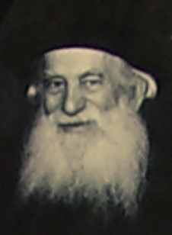
The Ponovezher Rav

In 1953, The Ponovezher Rav, Rav Yosef Kahaneman, zt”l, spent much of his time traveling to raise funds for his Torah institutions in Eretz Yisroel. On many of his trips, he was accompanied by
Dr. Moshe Rothschild. Once, when Dr. Rothschild was studying medicine in Rome, the Ponovezher Rav arrived there late one dark and rainy night. After checking in to his hotel, the Rav immediately called Dr. Rothschild and asked him to come over and pick him up, as the Rav had somewhere to go to right away.
Dr. Rothschild pointed out that it was very late and it was pouring rain outside, “Couldn’t the Rav possibly make this trip tomorrow?” he asked. The Rav said that it was important for him to go immediately. Dr. Rothschild therefore hired a taxi and went to get the Rav, and was shocked to hear that Rav Kahaneman wanted to go, in the rain, to the Arch of Titus!
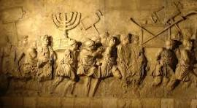
Portion of the Arch of Titus
When they arrived there, the Rav got out of the car and stood in front of the arch— which had carvings of the Bais HaMikdash being destroyed and its holy Keilim being looted and plundered. He shouted, “Titus! Where are you? You thought you would destroy us, and that your Roman empire would last forever! Where are you now? We are still here! We survived you, and we survived the Holocaust, and we rebuilt Torah in Eretz Yisroel!
“Where is your empire today?! You are dead, Titus! There is nothing left of your mighty empire. But I am here! My people are here! Torah is here! Judaism is alive and continues to live on!”

Reprinted from the Parshas Shoftim 5786 email of Rabbi Yehuda Winzelberg’s Torah U’Tefilah.

A Lesson from Shomayim (Heaven)

The Brisker Rav, zt”l, quoted a story that he heard from his father. His father emphasized that this story was a tradition in their family, and dated back to Rav Chaim Volozhiner, zt”l, who was the main student of the Vilna Gaon, zt”l.
The Rebetzin of the Gaon would collect Tzedakah for the poor, together with another woman. Every day, they would walk all over the cobblestone streets of Vilna, knocking on doors, and ask for whatever Tzedakah they could get in order to ease the difficult situation of the poor people of the city.
These two holy women were very close friends, and they made up with one another that whichever one of them left this world first would appear to the other in a dream and relate about her experience in the Olam HaEmes, the World of Truth.
As it turned out, the Rebetzin’s friend was the first to pass away, and the Rebetzin waited to hear how her good friend was doing in Olam Haba. It took a while, but she finally appeared to her, and she told the Rebetzin that she was not permitted to reveal anything about her experience in Shamayim.
However, since she had given her word, and in Shamayim a word is respected, she was permitted to reveal one thing. The Rebetzin listened attentively, and the friend said, “Do you remember some time ago that we visited the home of a certain woman to ask her for Tzedakah?
“Unfortunately, she was not home at the time. We left her home and began to walk down the block, when we saw her walking across the street. You raised your hand and pointed with your finger to show that she was walking on the opposite side of the street. We then both crossed the street and spoke with her, and the woman was quite generous in her contribution towards our cause.
“Concerning the actual donation, we both received credit in Shamayim for the steps that we took to go to her house, and when we continued along the street to see her. All of this is shared equally by both of us. However, the fact that you raised your hand and pointed with your finger in her direction, that too, is recorded in Shamayim, and that is where you earned more S’char than me. Your extra effort of
raising your arm to point goes to your individual merit!”
The lesson we learn from this is that there is absolutely nothing that is overlooked by Hashem. Every action and every bit of effort is all recorded on our behalf in Shamayim. Hashem takeseverything into consideration!

Reprinted from the Parshas Shoftim 5786 email of Rabbi Yehuda Winzelberg’s Torah U’Tefillah.

The Difficult “Nine Days” of Rabbi Baruch Mezhibuz
From the Desk of Yerachmiel Tilles

The ‘Nine Days’ leading up to Tisha b’Av—which commemorate the destruction of the Holy Temple—weighed heavily, like a dark cloud, over the court of the holy Rabbi Baruch of Mezhibuz, a grandson of the Baal Shem tov, which was usually permeated with an atmosphere of inner joy.
Even Yossele, one of the youngest and usually most cheerful of the chassidim, tried this time to silence the happy melodies he was accustomed to humming while bent over his books in study. Occasionally he would hum without thinking, until his friends reminded him sternly, “Yossele, have you already forgotten what our Rebbe said—that there is to be no singing or joy until the Nine Days are over?”
During these nine days of intensified mourning for the loss of the Temple, Rabbi Baruch would not see any of his followers. Rumors spread that each year on these days that he would set out on a personal “exile,” to feel, firsthand, the bitterness of exile that our ancestors experienced after the destruction—when they were taken en-masse to Rome and sold as slaves.
He would typically reappear at his doorway on the eve of Tisha B’Av, ready to read Eichah -- the Book of Lamentations. That year as well, Rabbi Baruch disappeared at the beginning of the Nine Days, and none of his chassidim saw him leave. The truth is, even had they seen him, they would not have recognized him—because he had disguised himself as a wagon driver, traveling across the country with a wagon and horses. He never used the same disguise twice, ensuring no one could recognize him.
This time, he chose to pose as a wagon driver because he felt weak in his legs. As he stood near his wagon, looking every bit the part, a Polish nobleman approached and hired him for a trip to a city about 70 kilometers from Rabbi Baruch’s hometown. The disguised Rebbe calculated that he would have just enough time to reach the destination and return before Tisha B’Av, with an extra day in case of delays. Rabbi Baruch set off, the nobleman sitting beside him. He traveled the dusty roads in silence, ignoring the traveler’s sharp-tongued remarks.
He sighed deeply at the sight of the old horses straining to pull the wagon, and quietly endured the jolts each time the wheels hit a rock or sank into the mud. They spent two nights at roadside inns. Of course, “the wagon driver” did not have a private room like the nobleman; each night he had to sleep on straw in the stable, beside his horses. Then, at the first rays of dawn, he would rise and strap on his tefillin so he could resume the journey while it was still early in the morning. Nothing noteworthy happened on the way there, aside from the usual hardships faced by any wagon driver.
But on their first night returning, the nobleman got drunk at the inn where they lodged. Before going to bed, he boasted loudly to anyone who would listen about the successful business deal he had made in the city. As is often the case in such situations, there were men nearby who were just waiting for such an opportunity. They were “ready” to deal with the wealthy traveler and “relieve” him of his money.
The next morning, when Rabbi Baruch awoke and roused the nobleman, he had to dress him himself and carry him to the wagon—he was still as drunk as Lot. Shortly after they left the inn, they entered a dense forest, empty of all life at that early hour. As far as the eye could see, there were no people or wagons, as the sun had only just begun to rise.
Suddenly, without warning, someone threw a sack over Rabbi Baruch’s head. When he regained consciousness, he found himself tied to a tree. Opposite him, the nobleman was also tied to a tree, seemingly unconscious. Were it not for the rope holding him upright, he would have collapsed to the ground. It became clear that bandits had ambushed them, emptied their pockets, and made off with the wagon and horses, which had vanished as if into thin air.
Rabbi Baruch noticed his tefillin lying in the grass—apparently of no interest to the thieves—as well as his small prayer book, without which he would never travel. His heart filled with joy at the sight of the tefillin and siddur, and he thanked G-d for sparing his life.
But the troubles were only beginning. With great effort and movement of his entire body, Rabbi Baruch managed to loosen the ropes binding him. He then untied the nobleman, picked up his tefillin, kissed them, and placed them in his double pouch used for travel. As for the nobleman—Rabbi Baruch managed to untie him, but he remained unconscious on the ground, barely clinging to life, his faint pulse the only sign he was still alive.
Rabbi Baruch could easily have left the man behind and made his way to the nearest settlement. But such a thought never even crossed his mind. He wandered a bit to find water, to wash the man’s face and try to revive him. After a few hours, the nobleman began to awaken from his stupor. When he finally came to, he asked Rabbi Baruch in confusion: “What happened? What’s going on? Why are we sitting here instead of traveling home in the wagon?”
In a quiet voice, imitating a simple, obedient wagon driver, Rabbi Baruch told him what had happened. When he mentioned that they had been robbed, the nobleman sprang up like a man bitten by a snake and cried out, “My money! Where is my money—the ten thousand rubles that were in my pocket?” He shouted and wailed, nearly losing his mind from the grief of losing his fortune.
It took Rabbi Baruch quite some time to calm him. Eventually, the nobleman sat on the ground, staring at a single point, as if hoping to find his lost money there. After a while, he began casting suspicious glances at Rabbi Baruch, who paid him no attention—he was deep in prayer. When Rabbi Baruch finished praying, he turned to the nobleman and asked, “Are you strong enough now to walk with me? Perhaps we’re not far from the inn, and we can make it back on foot—or at least reach a road or settlement.”
They began walking slowly, but hadn’t gone far when they heard voices—it was a group of hunters passing by. The nobleman’s joy knew no bounds when he recognized some of his friends among them. He told them what had happened and added that he suspected the wagon driver of collaborating with the bandits. “How else could the thieves have known I was carrying so much money?” he asked.
“Let’s shoot him!” one of the hunters suggested. The leader of the group, an older nobleman, thought otherwise. He proposed, “Let’s tie the wagon driver to a tree and wait. If he’s one of the thieves, his comrades will come to help him. If not—let G-d help him.”
“Indeed, G-d will help me,” thought Rabbi Baruch. The hunters left him alone in the forest. Night fell. Not a living soul was in the forest, only the pale light of the moon filtered through the thick trees. “It must be midnight,” Rabbi Baruch said to himself, seeing the moon directly overhead. With hot tears streaming down his cheeks, he began reciting Tikkun Chatzot, the midnight lament for the destruction of the Temple, something he recited every night.
Never had he felt the pain of exile so deeply as he did now, amidst anguish and suffering. It was as though the entire forest echoed his voice as he poured out the Psalms from his broken heart. Strangely, with every verse he recited, hope returned and found a place in his heart. It was as if the trees of the forest had joined together in a great choir mourning the destruction of the Temple, and the moon and stars above were trying to whisper that salvation was drawing near. “Hey, you there—wait a moment!”
The low voice that interrupted Rabbi Baruch’s prayer belonged to the old nobleman, the leader of the hunters, who had earlier objected to shooting him. Rabbi Baruch turned toward the voice and saw the man approaching, accompanied by a group of others.
“I wanted to see what became of you,” the nobleman said. “I just couldn’t believe you were one of the thieves. Meanwhile, we caught the robbers at the inn where you spent the night. They admitted that our friend had drunkenly revealed how much money he was carrying. So, I came back to help you.” From the depths of his heart, Rabbi Baruch thanked G-d for the sudden salvation, and expressed appreciation to the old noble as well, for his thoughtfulness. The old nobleman also gave him a horse, and left one of his servants with orders to escort Rabbi Baruch home. It was late at night when Rabbi Baruch arrived. He found his chassidim waiting anxiously for him. They had almost resigned themselves to the idea that the Rebbe would not return. Then they heard the sound of horse hooves, and in strode Rabbi Baruch—accompanied by the nobleman’s servant. That night, Rabbi Baruch and his chassidim read the Book of Lamentations and recited the Tisha B’Av dirges with profound emotion, deeper than they had ever experienced before. On the following Shabbat—Shabbat Nachamu, the Sabbath of Consolation—Rabbi Baruch sat with his followers and said: “Soon G-d will send us our righteous Messiah, who will redeem us from exile. And the darker the night, the more radiant the dawn will shine.”
Source: Adapted and supplemented from a translation of a weekly emailing five years ago of Sipurei Tzadikim. Why This Week? Tisha b’Av [2026: Wednesday, July 22, sunset – July 23, nightfall.]
Biographical note: Rabbi Boruch of Mezhibuz [1753 - 18 Kislev, 1811] was the son of R. Yechiel Ashkenazi and Adel, the daughter of the Baal Shem Tov. He moved from Tulchin to assume the Chasidic leadership in Mezhibuz, the town of his holy grandfather. He was one of the pre-eminent Rebbes in the generation of the disciples of the Maggid of Mezritch and had thousands of Chasidim.

Reprinted from the Parshat Va’etchanan 5786 email of KabbalaOnline.org

